vega-devtools-mcp RN London Conf: Vega hands-on workshop

Title: Vega App Development Hands On Workshop Guide
Duration: 4 hours
Objective: Create feature-rich and performant Vega Apps using AI-Powered Vega Developer Tools

Prerequisites

1. Install Vega Developer Tools
Install Vega SDK and VS Code extension:
- Vega SDK - Download and Installation Guide
- Vega Studio Extension - Install from VS Code Extension Marketplace

Workshop Structure

Phase 1: Create a Hello World app

1.1: Environment Setup
Verify your Vega CLI version

run kepler --version command in a terminal window and confirm version is 0.21.4726 or higher

Launch VS Code and verify the Vega Studio side bar appears in VS Code
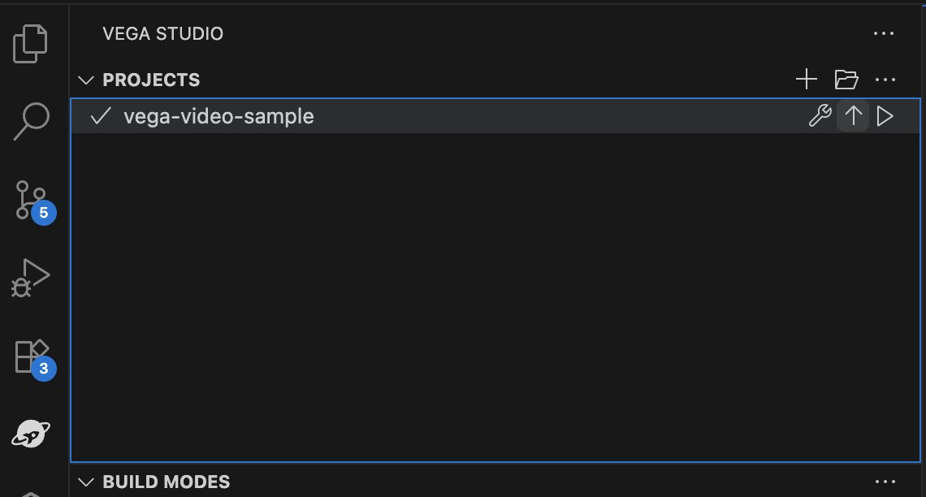

1.2: Create Your First Vega App (Hello World)
Create Hello World App:

In the VS Code Command Pallet, run “Vega Project: Create a new Vega project” command and follow steps in the interactive wizard to create the project
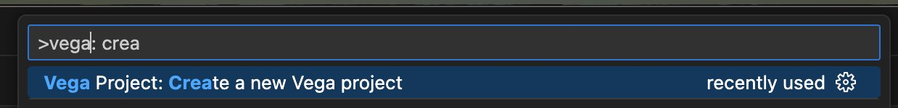

Use the “Hello World” template.
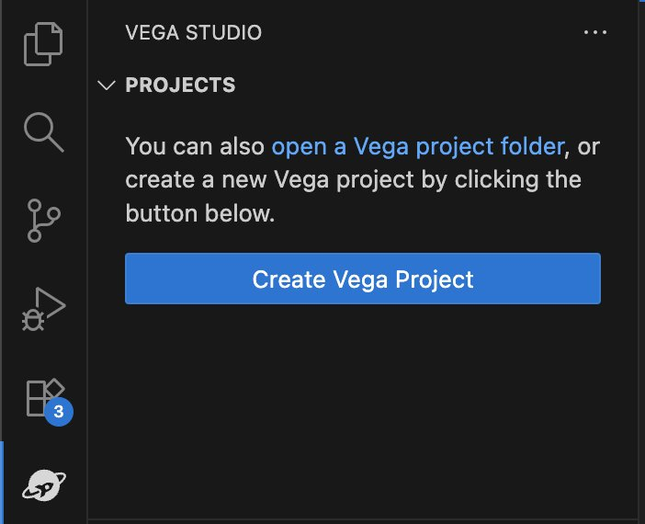

VegaStudio asks for a directory to save the project, select one from your workspace

Provide a name for your project:
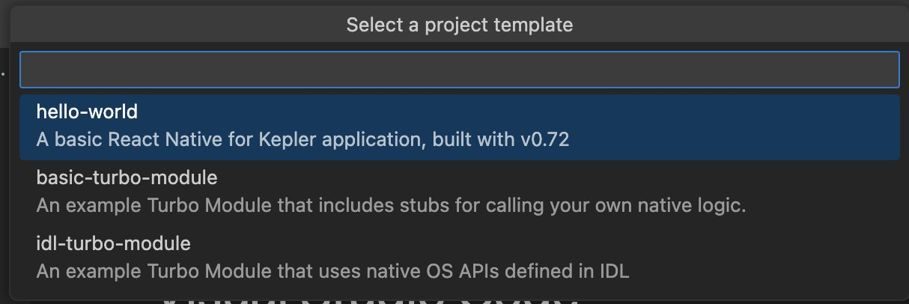

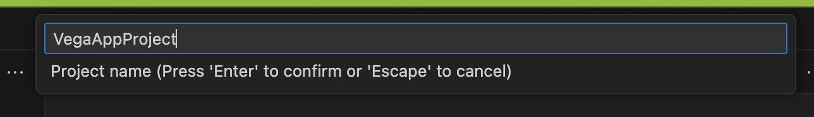
Add a package ID:
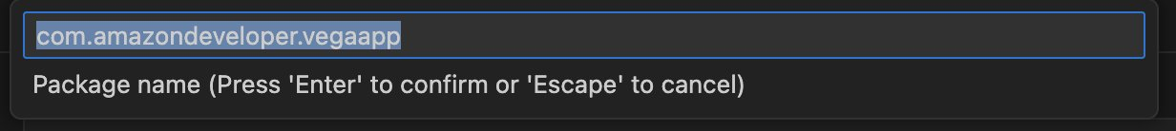
Open Your Created Project in VS Code (if it’s not already open)
Commit changes (Optional, but Recommended )
Run git init in a terminal window in the App project directory and then git commit to commit the initial code.

1.3: Test Hello World App
Vega Studio:
Click on the play icon next to the app project in the Vega side bar.

Note: You can start your app in “Debug” mode, which we generally recommend as this enables Fast Refresh and debugging breakpoints (but is slower), or “Release” mode which is faster and what you would use for submitting your app to the Appstore (but does not allow for fast refresh/breakpoints).

This will install and run the app on the Vega Virtual Device or FireTV Stick
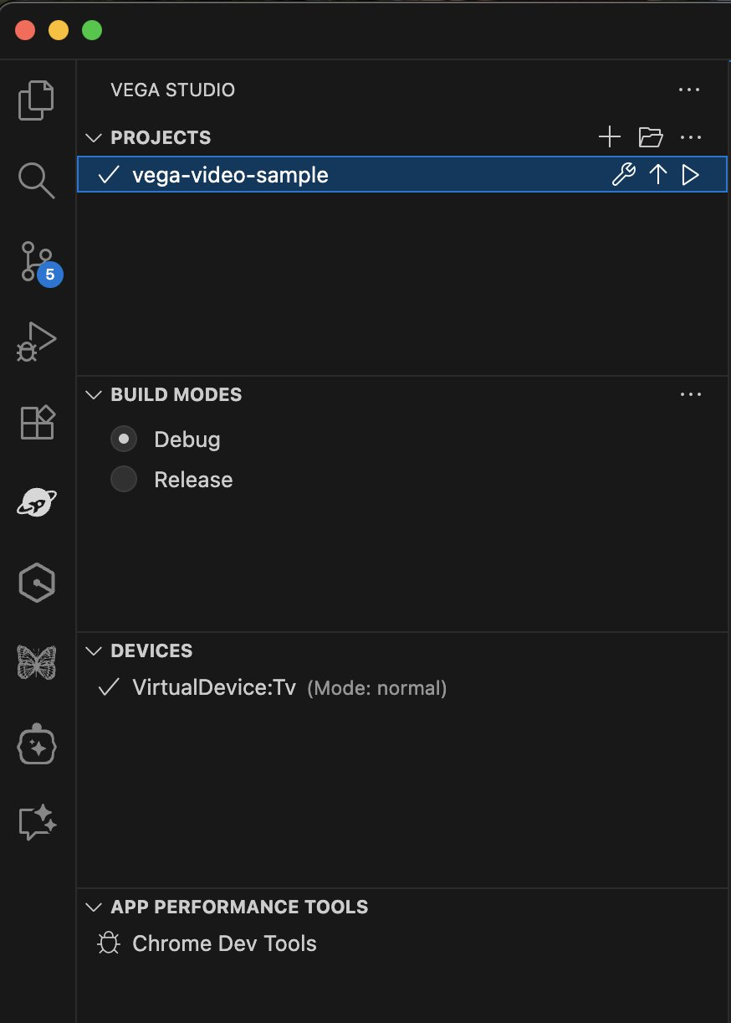
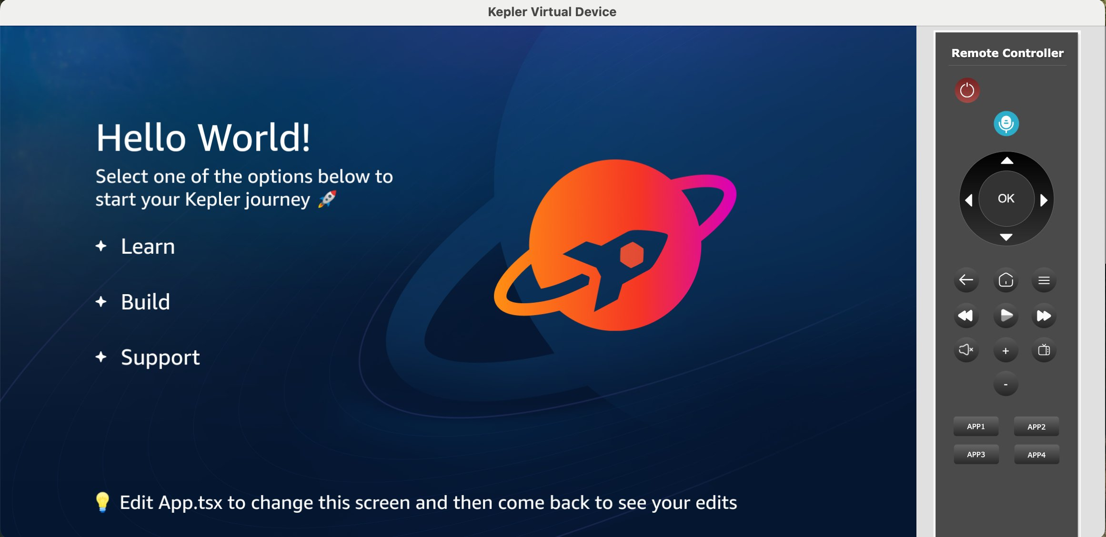

Recommended Testing (Optional)

Fast Refresh (hot reload)

Modify text in App.tsx to confirm fast refresh is working - this will make the rest of the steps of creating your Vega app significantly easier and faster
Breakpoints - you can open Chrome Dev Tools within Vega Studio and add a breakpoint to line 38:
setImage(images.learn);

when you press the Learn button, your editor should “break” and you should see the current variables/etc
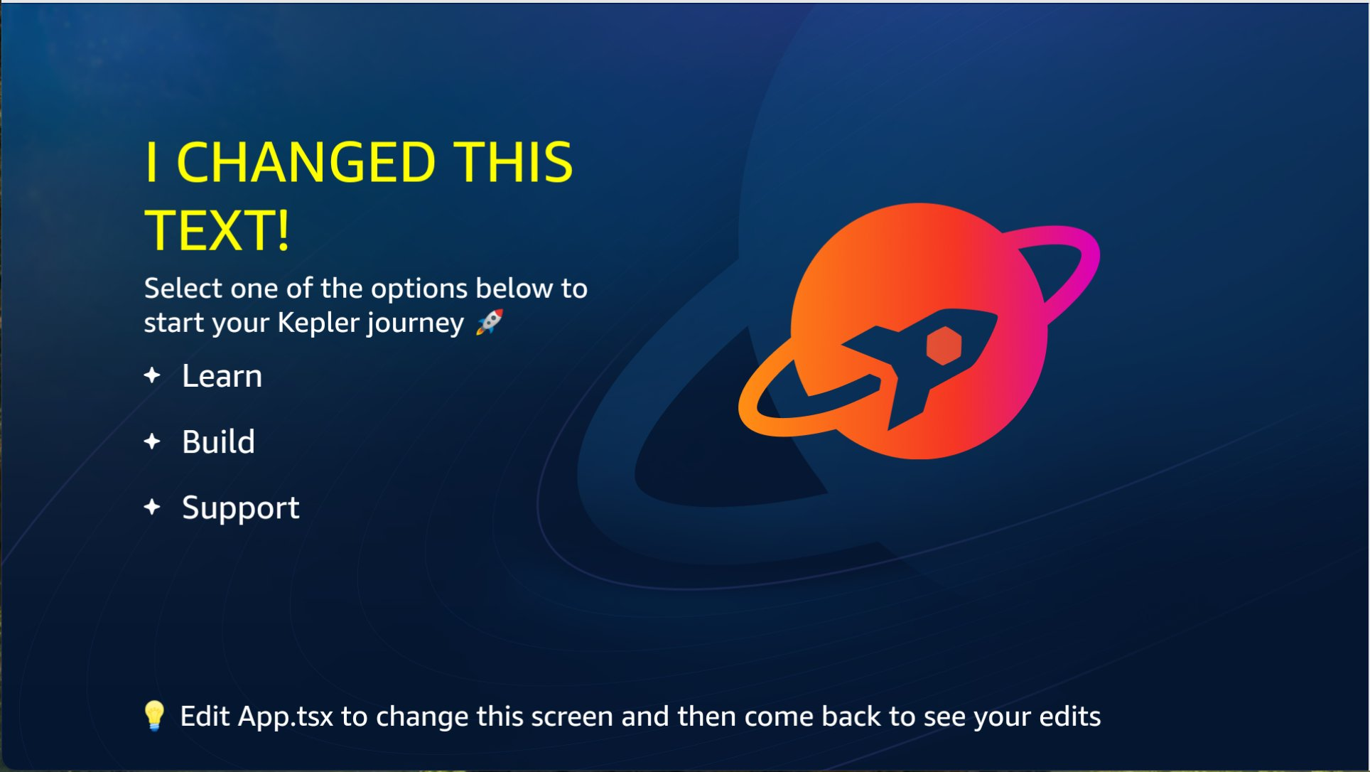

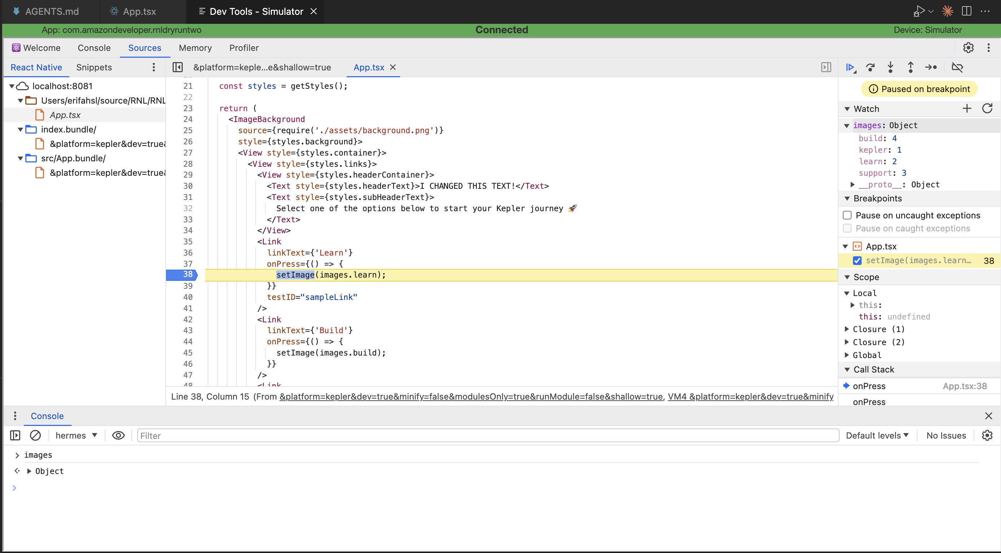

Phase 2: Set up MCP Server

2.1 Install & Configure Vega MCP Server
While you can use most AI Agent models as-is to make changes to the Vega Hello World App, for better results developing Vega Apps with AI we have a Vega MCP server to provide additional relevant context to your AI Agent. Below we walk through the three required steps to set up the Vega MCP server with your Vega project.

ℹ️ The steps in these guide have been tested with Claude Sonnet 3.5, 4 & 4.5. While we expect other models to behave similarly, we cannot control the response of every model.

ℹ️ Don’t have an AI agent/tool? Try Amazon Kiro, it comes with 500 free credits upon first use and should more than suffice for this workshop: https://kiro.dev/. We use it quite a bit and is one of our favorites!

Download our Vega MCP Server tarball (in the future we will improve this experience, but for now it requires a manual download) - Download vega-devtools-mcp.tgz . Note down the download path

Run an npm install from the tarball as global scope (or local to your project if you prefer)
$ npm install -g {PATH_TO_DOWNLOADED_FOLDER/vega-devtools-mcp.tgz
You will now need to add the MCP configuration in your AI Agent's MCP settings.
First, run the following command to get the binary location and copy the location
% which vega-devtools-mcp
And you’ll get an output that could be something like:
/Users/YOUR_HOME_FOLDER/.nvm/versions/node/v20.19.4/bin/vega-devtools-mcp
or the following if node installed via homebrew
/opt/homebrew/bin/vega-devtools-mcp

Save this path to your clipboard or another text file, you will need for the next step, which is the update the relevant
{
"mcpServers|servers": {
...,
"vega-devtools-mcp": {
"type": "stdio",
"command": "node",
"args": [
"{YOUR_PATH_TO_VEGA-DEVTOOLS-MCP_BINARY}"
]
}
}
}
 | AI Agent | MCP Settings File Location
1 | Cursor | ~/.cursor/mcp.json
2 | Github Copilot | ~/.config/mcp-config.json  <project-root>/.vscode/mcp.json
3 | Claude Code CLI | ~/.claude.json  /Library/Application Support/ClaudeCode/managed-mcp.json
4 | Amazon Q | ~/.aws/amazonq/mcp.json
5 | Kiro | ~/.kiro/settings/mcp.json
6 | Cline | ~/Library/Application Support/Code/User/globalStorage/saoudrizwan.claude-dev/settings/cline_mcp_settings.json
7
Note that for those using Claude Code, you can add the MCP server via command line similar to the following:
claude mcp add --transport stdio vega-devtools-mcp -- node {YOUR_PATH_TO_VEGA-DEVTOOLS-MCP_BINARY}
ℹ️ Important:Start the MCP Server from Agent’s MCP config, if not already started - check your current running MCPs to ensure the vega-devtools-mcp is listed as running/connected.

2.2 Add Vega Context to AI Agent
The final step to using the MCP server is to add specific project configuration to look up additional prompts/context when using Vega-specific commands/components/libraries/etc. Make sure you are in your project directory.

Run the following command within your App project, to initialize Vega context for your AI Coding agent.
npx vega-devtools-mcp --init-context
Choose the AI Agent from the list. Enter 7 for “Other” AI agents not included in the list, to manually copy the Vega context in your project directory
% npx vega-devtools-mcp --init-context
====================================================
🚀 Vega Developer Tools - Initialize Vega Context
====================================================
This tool installs Vega App development context document in your project.
The context document guides AI agents to efficiently answer queries related to app development for Vega OS
Choose from the following options to automatically install Agent specific preset in your app project:
1. Cursor - Adds AGENTS.md file
2. Claude Code - Adds CLAUDE.md file
3. GitHub Copilot - Adds AGENTS.md file
4. Amazon Q - Adds .amazonq/rules/ directory
5. Kiro - Adds .kiro/steering/ directory
6. Cline - Adds .clinerules/ directory
7. Other AI agent or custom setup - View content only
Select an AI agent (1-7):
 | AI Agent | Project Context Location
1 | Cursor | project-root/AGENTS.md file
2 | Claude Code | project-root/CLAUDE.md file
3 | Github Copilot | project-root/AGENTS.md file
4 | Amazon Q | project-root/.amazonq/rules folder
5 | Kiro | project-root/.kiro/steering folder
6 | Cline | project-root/.clinerules/ folder
If these do not properly load for you, you can always say the following at the start of any AI agent session: use AGENTS.md for context

Verify AI agent is configured with Vega Context: In your AI Agent's chat interface, run the following prompt
Can you describe the Vega Platform Architecture in one sentence.
ℹ️ Important: ensure the MCP tool read_document is triggered! You will need to grant permission to read, we recommend always allowing for the given workspace. It may look something like the following:

vega-devtools-mcp - read_document (MCP)(document_name: "react_native_for_vega_architecture.md")
⎿ #react_native_for_vega_architecture.md
## High-Level Architecture
… +59 lines (ctrl+o to expand)
or the following with an AI IDE or extension:
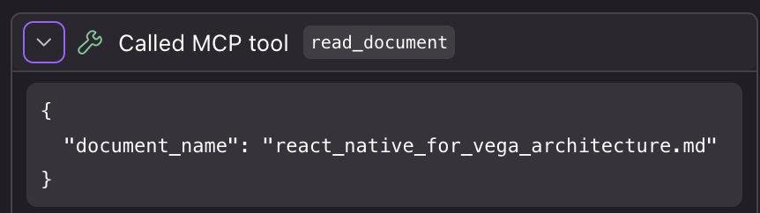

You should get a response similar to
Vega is a TV platform that uses a system-bundled React Native runtime (rather than app-bundled), where
applications only package their JavaScript code and dynamically link to the OS-provided React Native
framework and native services at runtime for optimized performance and resource sharing.
Verify if AI Agent made a tool call to vega-devtools-mcp to read Vega Architecture document.
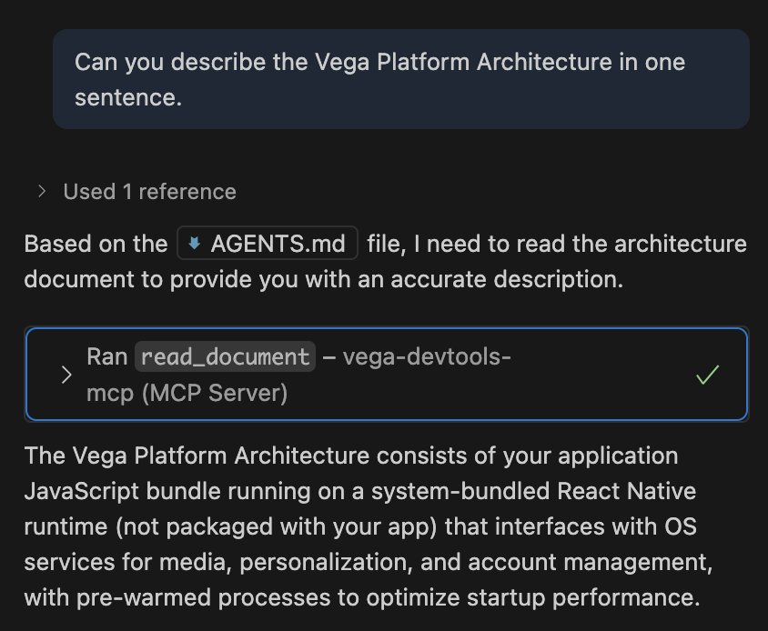

[Optional] Use AI To Run Your App via the Vega CLI
We generally recommend to use the Vega Studio UI to run your app on-device, but we have provided options to run via your AI agent and the Kepler CLI. Depending on your agent, you may have to run “npm start” in a separate terminal manually - this is the Metro server which will also contain the app logs (e.g. console.log).

Steps:

[1] In your AI Agent's chat interface, run the following prompt - "Run my Vega app on the Vega virtual device in debug mode with fast refresh".
You should expect the AI agent to run the following tools in order to run your app
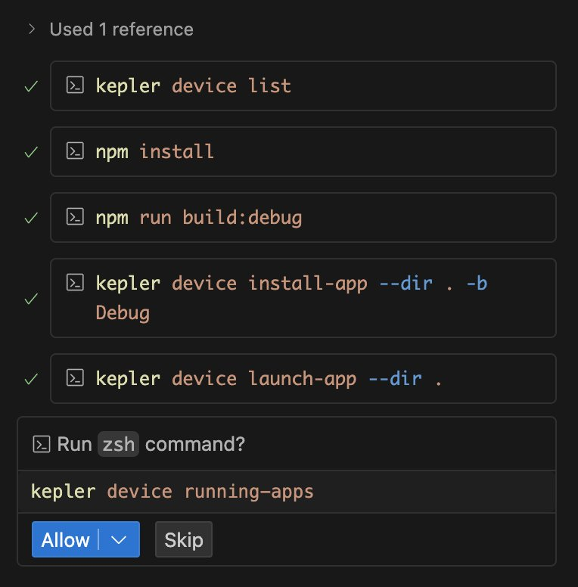

Verify app launches successfully and test basic functionality. Make a change in the App and verify it reflects in the running app
Skip npm start skip in the AI agent, by click skip and start it manually in a terminal window
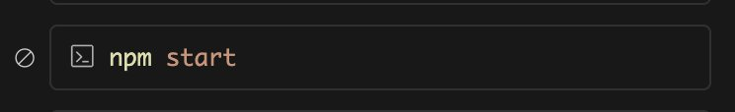

Phase 3: Create a 3 screen app
Now the fun part! We are going to build our TV-based UI, a basic 3-screen video streaming app with some AI-generated videos.

If you do not wish to use AI (or were unable to use AI), you can always follow our tutorial on our tech docs: https://developer.amazon.com/docs/vega-tutorial/0.21/introduction.html

3.1: Add a home screen
First we are going create a home screen component that will replace the main screen from the hello world app. This home screen will contains a grid of movie titles (that we will retrieve via a network API call) and eventually allow the user to play back one of these titles. We are going to use AI Prompts (with our Vega MCP server) to assist us in developing.

Important: AI is literally different every time and can make mistakes. It is important that you ensure each step is working BEFORE you proceed to the next step because it gets progressively harder to debug the farther you get (IE if your app is crashing, do not proceed until you resolve the error). We also highly recommend you inspect each code diff as you go along and also “git commit” after each step so you have an easy way to roll back any broken code. Raise your hand or flag us down if you get stuck at any point.

Add a home screen component, Prompt:
For this Vega app, I want to create a new component called HomeScreen with just some placeholder text of “Home Screen”. And I want to replace the content of App.tsx with HomeScreen and it should take up the entire screen.

Assuming you have Fast Refresh enabled, your app UI should automatically update to something like the following:
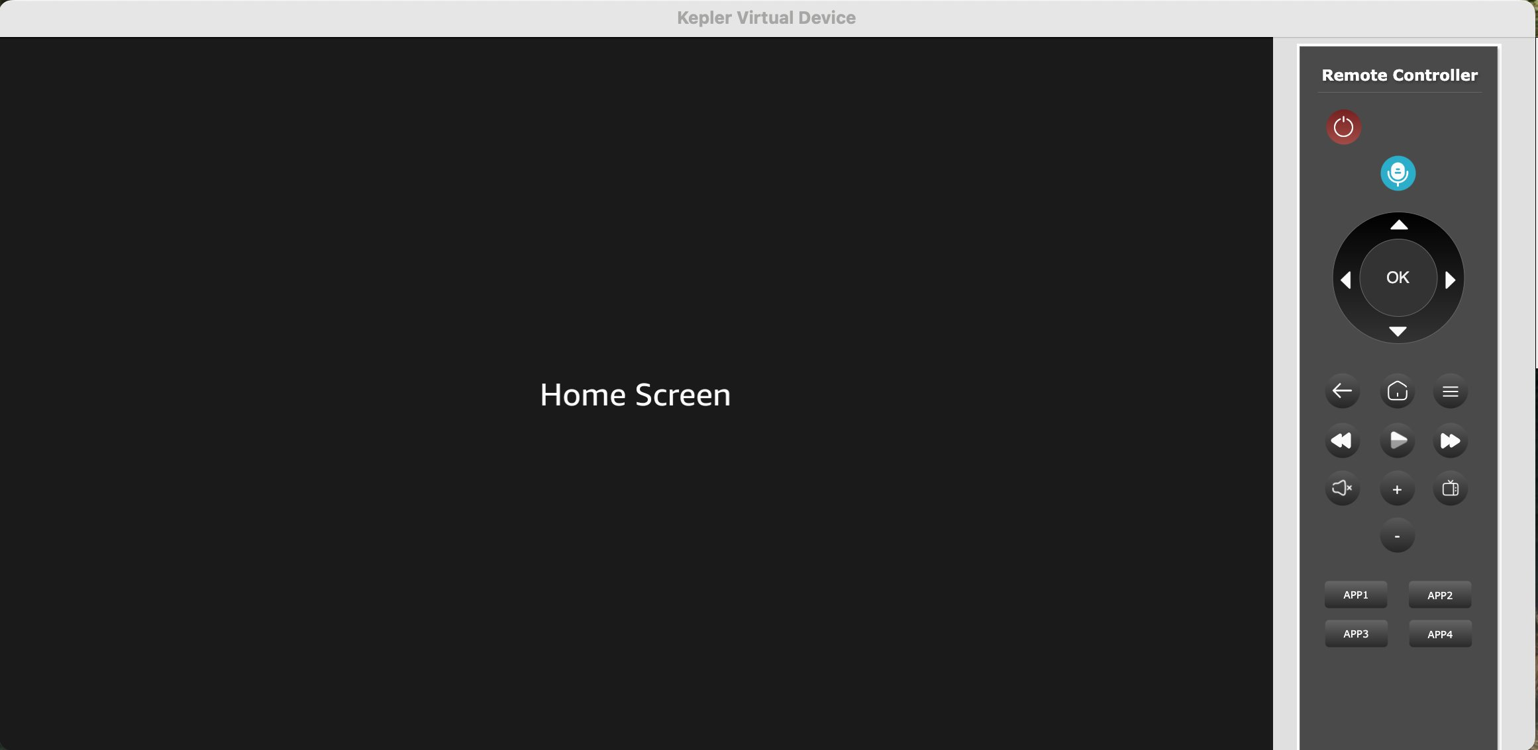

You should have a new HomeScreen.txt (likely in a new “screens” folder) with content similar to this:
import React from 'react';
import {View, Text, StyleSheet} from 'react-native';
export const HomeScreen = () => {
return (
<View style={styles.container}>
<Text style={styles.text}>Home Screen</Text>
</View>
);
};
const styles = StyleSheet.create({
container: {
flex: 1,
justifyContent: 'center',
alignItems: 'center',
backgroundColor: '#1a1a1a',
},
text: {
fontSize: 48,
color: '#FFFFFF',
},
});
It’s perfectly OK if your code doesn’t look exactly the same. Your App.tsx should be something similar to this:
And the App.tsx should be something similar to this:
import React from 'react';
import {HomeScreen} from './screens/HomeScreen';
export const App = () => {
return <HomeScreen />;
};
Next we are going to build the main content of our HomeScreen, which will be a row of content with some sample movie data that we will fetch from a hosted JSON file. Take a quick look at the file for the data structure; notice we have a list of items with ID, title, description, images, and an mp4 video file for each. We are going to use this metadata to populate our row and eventually create a details screen and video playback screen.
We will use the following prompt, make sure you read it all. The benefit of using prompts is that we can use natural language to describe the experience we want to build, while still specifying some technical direction and details. Prompt:

I want to update HomeScreen to list movie content titles that the user can watch. It will contain a single row of content that we will first retrieve via a fetch call to: https://raw.githubusercontent.com/efahsl/scrap-tv-feed/refs/heads/main/catalog-fullUrls-720p.json. Check the data structure from the API. The content should be displayed as 16:9 thumbnail images in a FlatList that should be focusable via d-pad remote control and look OK when viewed far away at 10 foot.
Use the thumbnail image (not the poster image) for display, and each item should be about 400px wide (and thus 225px tall). I also want a small header above my content row called “Latest Releases”. Pressing the item should result in just a console log statement for now. I’d like a white border around the actively focused element.
Let me know if you want me to clarify any questions you have before we begin (but also provide a recommendation/suggestion for any question)?
We like to include a question at the end of our prompt to resolve any ambiguity in our prompt; your Agent may or may not ask you some follow-up questions.

Once complete, you should have a UI that looks something like the below image:
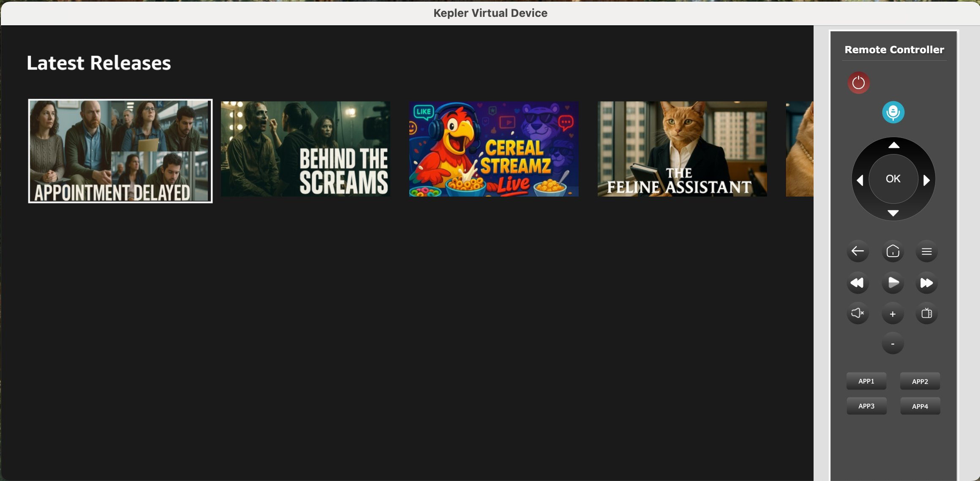

Optional: modify styling. Since we are going to be using TV Directional-Pad (D-Pad) controls to drive the experience, we will need to understand what item is selected. There should be some basic indicator of what is selected, but consider modifying the style such as setting/changing a background color when focused or setting/changing the scale transform to 1.15. Try using natural language to describe any changes you’d like to make. OR go into the code of your HomeScreen.tsx and make these changes directly.

Commit changes to save your work: git add * / git commit

2.2: Add a details screen
Now we are going to add a second screen we can navigate to from our Home Screen. First we need to create navigation, we’ll use a Stack Navigator. Then we’ll create a Details Screen to confirm the content that was selected before we start playing it back.

Add a Stack Navigator:

Create a new Vega stack navigator for my project. The Home Screen should be the default (and only) route for now.

We should see our package.json updated with the following dependencies:
"@amazon-devices/react-navigation__native": "~7.0.0",
"@amazon-devices/react-navigation__native-stack": "~7.0.0",
"@amazon-devices/react-native-screens": "~2.0.0",
You may need to run npm install to install these dependencies

You App.tsx may look something like the following:

const Stack = createNativeStackNavigator<RootStackParamList>();
export const App = () => {
return (
<NavigationContainer>
<Stack.Navigator
initialRouteName="Home"
screenOptions={{
headerShown: false,
}}>
<Stack.Screen name="Home" component={HomeScreen} />
</Stack.Navigator>
</NavigationContainer>
);
};
If your app loads up properly and shows your Home Screen without errors, you may continue.

Now let’s build the actual DetailsScreen, prompt (again, make sure you read and understand what we’re doing):

Create a new DetailsScreen component. This screen will be accessed via our stack navigator when the user presses one of the content items from the Landing page. This Details Screen should use the “banner” image from the item data which takes up the entire background of the screen and display text for the title and description (make sure these are readable on top of the background image). Add the following props to the component and pass them via navigation: banner image, title, description, and video URL.

A lot of activity happening here. One thing to note is that in your Home Screen you should now see navigation wired up upon button press, something like the following:

const handleItemPress = (item: MovieItem) => {
navigation.navigate('Detail', {
bannerImage: item.images.poster_16x9,
title: item.title,
description: item.description,
videoUrl: item.sources[0]?.url || '',
});
};
You should now be able to navigate to your detail screen, and press the “back” button (or “Esc” key) to go back to the home screen.
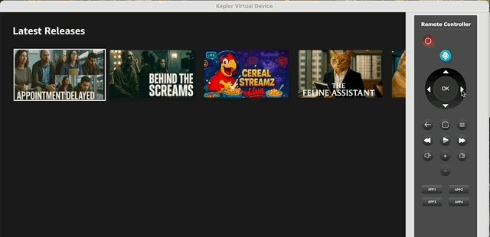

Add actions/buttons to the screen. Now let’s add some buttons to the screen so we can do something - we’ll add a “Play” button which will bring us to a new Video Playback Screen (to be built next) and an “Add to watchlist” button that is a placeholder and won’t be built in this workshop (though you can try doing it yourself if you like!) Prompt:
Add "Play" and "Add to watchlist" buttons to my DetailsScreen; the button presses should log an acknowledgment message in the logs". Make sure the buttons indicate which one is focused; the "Play" button should be focused by default.
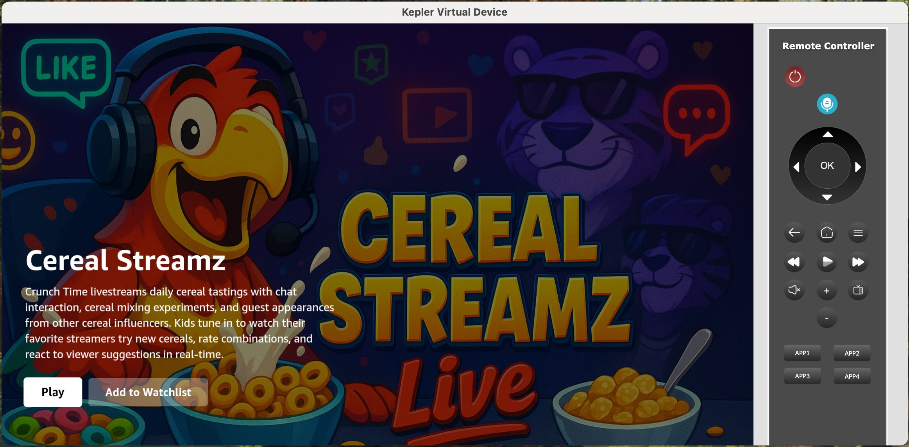
Commit changes for safe-measure (git add * / git commit)

2.3: Add a media player
OK now we’re going to add a video player. Note that with Vega we are using W3C Media APIs, of which you can read up more HERE (link to be added). Our Vega media player has two options:
- URL mode - for playing simple content like flat mp4 files
- MSE (Media Source Extensions) - for playing “adaptive” content including live content, DRM, 4K, etc.
For this workshop, we’re going to use URL mode as we’re just dealing with simple flat files. But most media streaming apps will need to use MSE mode and likely a video player library like Shaka Player, Bitmovin, or others.

Add Media Player, In your AI Agent's chat interface, run the following prompt:
Add a new VideoPlayerScreen following the Vega Video Player Example. Add it to the existing navigation structure - the video URL should be passed/linked from the Detail Screen when the user presses the "Play Video" button

Given that we are updating app manifest entries, you will likely need to rebuild/relaunch your app.

To test your app, navigate to the details page and play the video. Note that the Vega Virtual Device at times has trouble playing mp4 videos with a “debug” build. To remedy, you can run a “release” build which should have better stability (but you can’t use Fast Refresh) or run on a Fire TV Stick which is the next section.

(Commit changes)

2.4 Additional enhancements
Let’s make our Home Screen a little more realistic by using multiple rows and categories of content. use the following prompt:

On the HomeScreen, instead of a single row of content we want to have multiple content rows based off the “category” value from the data (re-check the data by grabbing the data from the URL again). I also want a new first row of data called “Trending Now” which would be content with the “trending” value of “true”.

Let’s add a focus management improvement, prompt:
I want to trap focus on each row, such that when I am at the end of a row, when I press “right”, the focus should NOT go down to the next row.
This should import TvFocusGuideView (if it’s not already included - and you may have to “npm install” again) and implement the trapFocusLeft and trapFocusRight props.
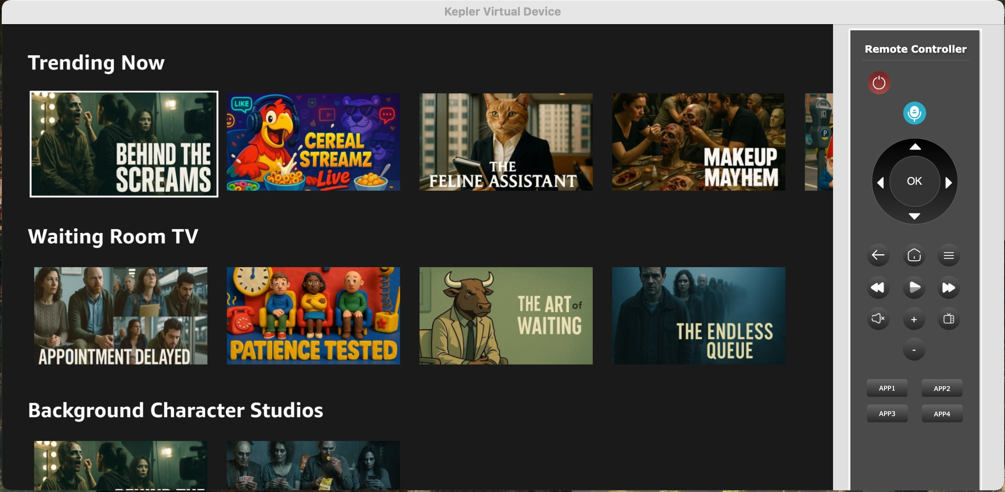
Finally, since our videos are short, let’s add some logic that once the content finishes playing, it goes back to the previous detail screen:
On the Video Playback Screen, when the video playback is "done", I want to go back to the previous screen automatically.

Your agent should import your navigation reference via a prop and add in an event listener for “ended” (same as HTML5):
// Add event listener for when video ends
video.current.addEventListener('ended', handleVideoEnded);
...
const handleVideoEnded = () => {
console.log('Video playback ended, navigating back');
navigation.goBack();
};

Phase 4: Performance Testing & Analysis
Next, lets run the app on a physical FireTV stick to test the actual 10-foot experience and run some performance tests to get a performance baseline.

4.1: Run the App on FireTV Stick (X minutes)
In this milestone, lets connect the FireTV Stick to the development machine and test our app on the device
If you have already setup and ran your app on a FireTV stick, you can skip this milestone

Steps:
- Connect your FireTV stick to your development machine via. the USB cable
- If you have a HDMI Capture card, connect the HDMI port of the FireTV Stick to the capture card, then connect the capture card to your development machine
- You should see the FireTV UI in Quicktime player on your Mac, under “New Movie Recording”
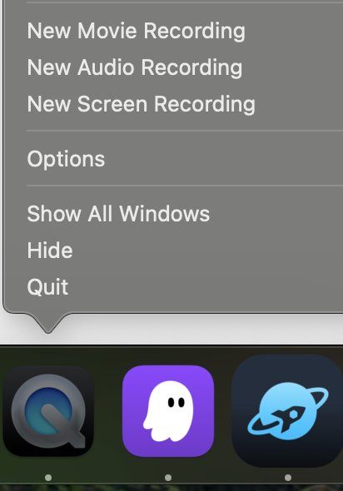
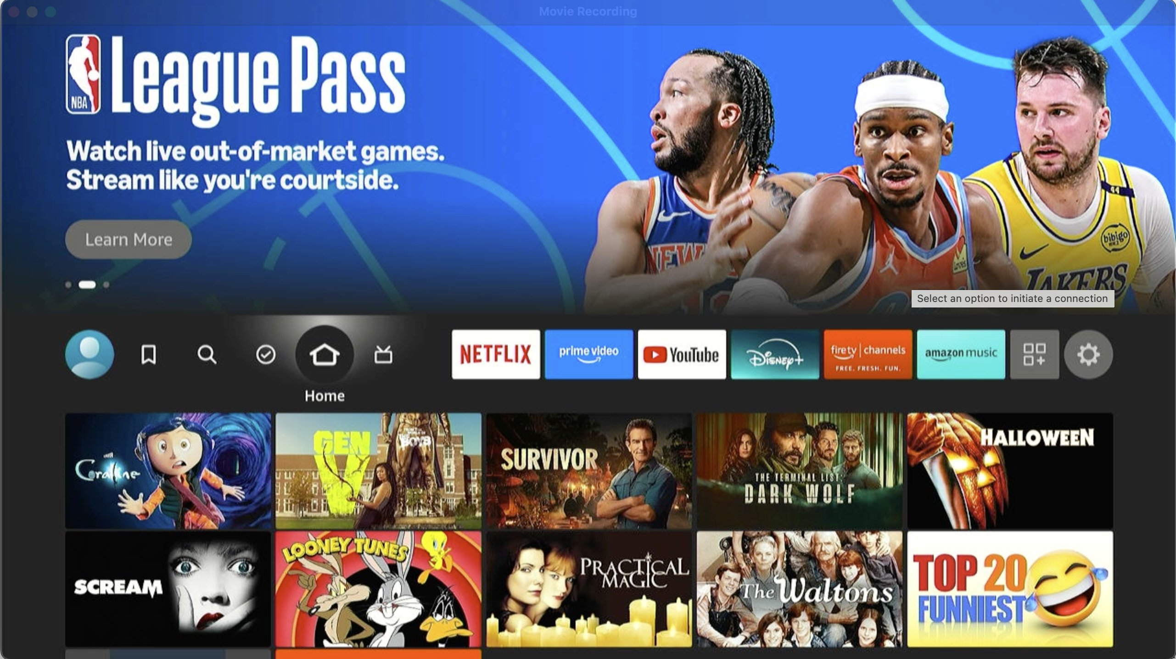
- Complete login and registration steps on the FireTV stick using your FireTV Stick Remote
- Run your app
  - In Vega Studio side bar, select the FireTV Stick device under “Devices” panel and “Release” under “Build Modes’, then click the play icon next to the project to build and run the app on the device
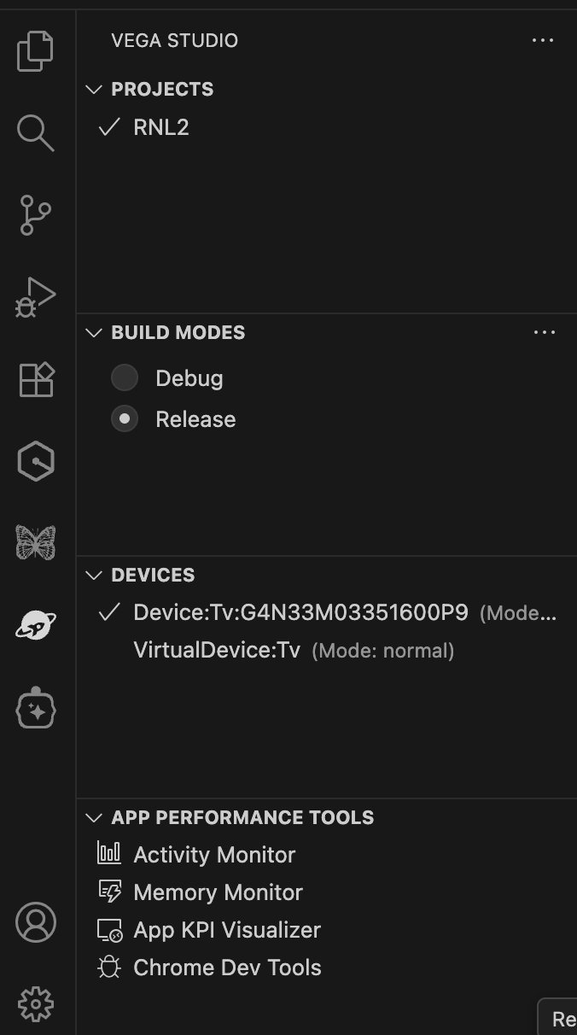

4.1: Performance Analysis (X minutes)
In this milestone, we will run a performance test on the app on a physical device to get a performance baseline.
This is required to accurately measure performance, apply targeted performance optimizations and re-measure to verify performance improvements.
Steps:
- Run Performance Performance test:
  - Connect a FireTV stick device and run “App KPI Visualizer” tool from Vega Studio side bar in VS Code
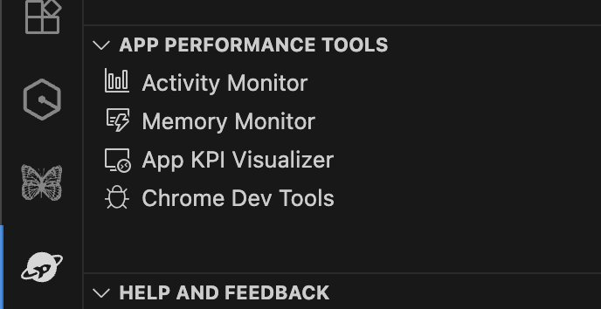
    - Select following options in the wizard:
      - KPIs: Choose - ‘Cool Start Latency’ and ‘UI Fluidity’ tests
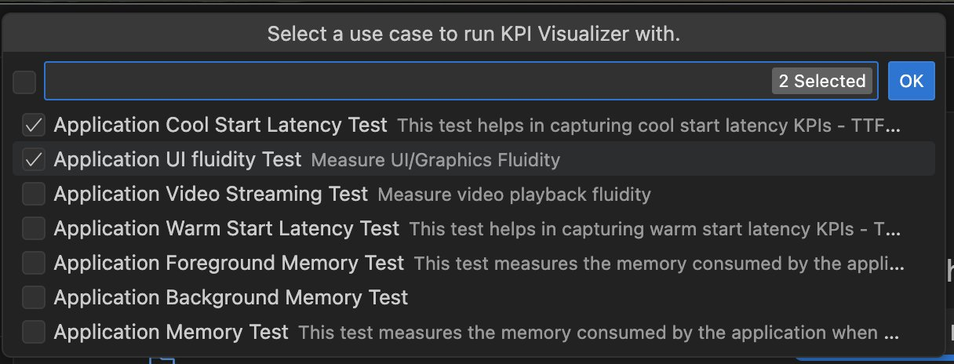
      - Uncheck “Record CPU Profiler” - this option records a CPU profiler trace to deep-dive further into performance issues
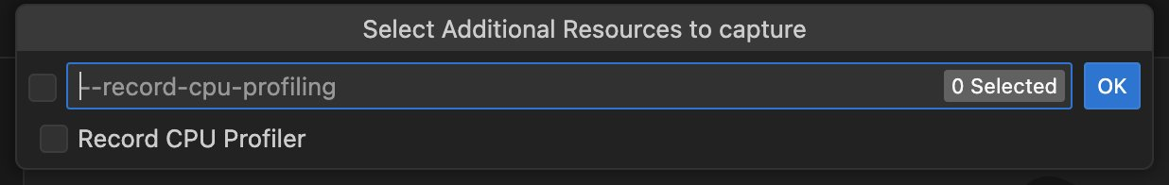
      - Select “No” for the following:
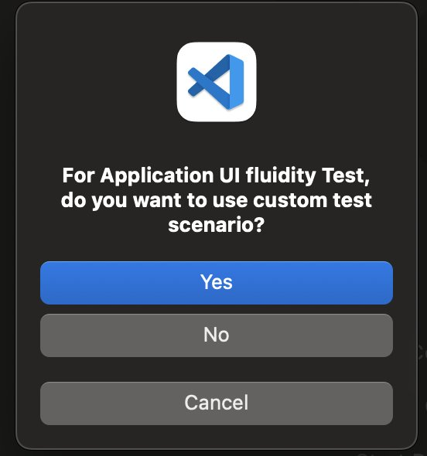
      - Select defaults for all other options in the wizard
      - Once KPI Visualizer starts, you should see a notification window as below
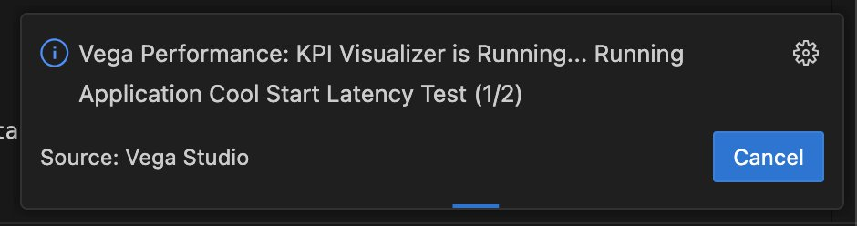
- Analyze performance report
  - Performance report is automatically opened after performance test is completed
  - Check which KPIs are failing

4.2: AI-Assisted Diagnosis (X minutes)
- Diagnose performance issues
  - For failing KPIs, click “Diagnose with AI” action shown in the KPI report to diagnose a failing KPI
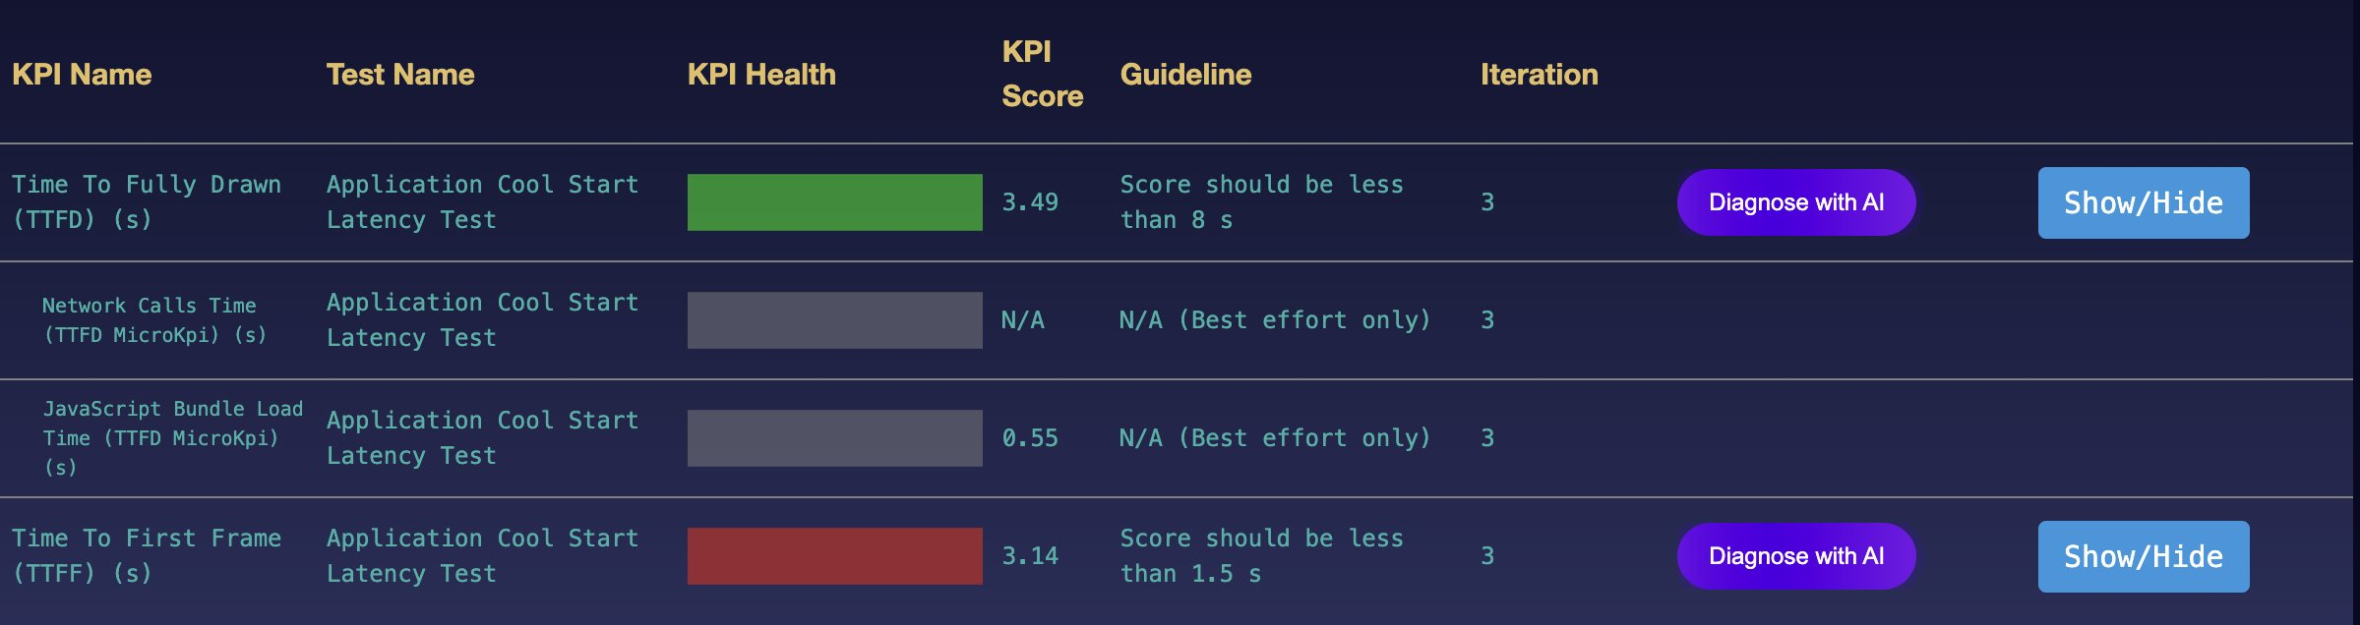
  - Review & apply suggested optimizations
  - Re-run performance test

Phase 5: Performance Improvements

Use Vega Native UI Components
The existing FlatList implementation is a bit slow, especially when running on the physical Vega device. Vega has a Native Carousel component as part of the kepler-ui-components library, which also provides us additional UX options more fit for TV (maintaining the focus position fixed to the left-most element of the screen). Let’s replace our FlatList with the following prompt:

I want to replace my existing FlatList Rows on HomeScreen.tsx with the Vega Kepler Carousel component from the "@amazon-devices/kepler-ui-components" library (update my package.json and npm install if necessary). Migrate our existing FlatList (using the same image and dimensions) over to the Carousel. I also want to use the FocusIndicator of "fixed" on the Carousel props. Any questions?

You should now see the content row “slide” behind your focused item and it should be MUCH faster especially on-device. Try running your performance tools again for UI fluidity to see a faster set of results.

Wrap-up
TBA

Appendix

The below are the key milestones we are going to anchor around

- Setup complete - SDK & Dev Tools downloaded 1. Install Vega Developer Tools
- Hello World and Fast Refresh - whether by Vega Studio (ideal) or AI prompts Phase 1: Create a Hello World app
- 3-screen video app (on VVD) - create via prompts or use the existing tutorial Phase 2: Create a 3 screen app
- Set up and run app on Callie - notice perf differences
- Run perf tools on Callie Phase 3: Performance Testing & Analysis
- App Optimizations - replace flatlist with native carousel. re-run perf tools
- User’s choice - create a different app (inspired from options below), continue enhancing existing media app, submit to appstore
- Provide feedback - verbally Q&A type feedback followed by survey to be shared

